Support H.357, sponsored by Rep. Curt McCormack

What is wanton waste?
In general, the term “wanton waste” describes behavior that intentionally wastes something negligently or inappropriately. With respect to hunting, if refers to killing, or attempting to kill, a wild animal and failing to remove that animal from the land and utilize it for a useful purpose such as consumption of the meat or use of the fur. Because our state’s wildlife is considered a public resource, behavior that results in wanton or needless killing of wildlife should be opposed by all Vermonters.

Does this happen in Vermont?
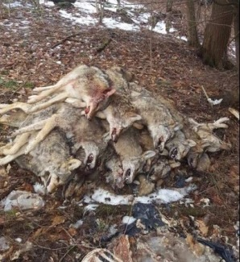
In 2009, a survey of Vermont game wardens revealed that "hunters and anglers are not consistent in their efforts to retrieve fish and wildlife.” The Department estimated that as many as 60 to 100 wanton waste events occurred each year — many of which are very apparent to the public. In response, the Department supported the enactment of a rule against wanton waste, but it was blocked by the Fish and Wildlife Board.

While most evident in the piles of dead crows or coyotes killed for recreation or target practice and left to rot, wasteful killing also occurs with deer, bears, and other “big game” species. According to a retired Vermont warden in an April 2018 letter to Department of Fish and Wildlife management, “During my career as a state game warden I have seen bears, deer and wild turkeys that were harvested, hung and left to rot. I have also witnessed numerous spring shot muskrats, pelts intact, discarded by the side of the road.”

Why is wanton waste unacceptable?
Wanton waste clearly violates the North American Wildlife Conservation Model’s prohibition against the casual killing of wildlife for reasons other than food and fur, self-defense and property protection. The failure to remove killed wildlife from the land also creates problems for other wild animals by allowing bodies that are often riddled with lead bullet fragments to rot and be consumed by raptors and other wildlife, exposing them to the deadly effects of lead poisoning.

What would H.357 do to solve the problem?
H.357 would not prohibit or curtail lawful hunting in Vermont. Instead, it prohibits unethical, wasteful practices that undermine efforts to promote appropriate hunting behavior.

Specifically, the bill would prohibit a person from intentionally leaving wounded or killed game, fur-bearing species, wild birds, or other wildlife in the field or forest without making a reasonable effort to retrieve and consume or use the game, fur-bearing species, wild birds, or other wildlife.

